**E-Farm Fresh Grocer**

**SUBMITED BY:**

1. Rushikesh Ahire.
2. Rohini Patil.



**Department Of Computer Science.**

**K. K. Wagh Arts Commerce, Science, & Computer Science,**

**Colleg­e.Nashik-422003**

**Academic Year 2018-2019**



**Karmaveer Kakasaheb Wagh Education Society’s**

**K. K. Wagh Arts Commerce, Science, & Computer Science Colleg­e Saraswati Nagar, Nashik-422003**

**C E R T I F I C A T E**

This is to certify that,

**Mr./Miss.** Rushikesh S. Ahire & Rohini P. Patil

Has satisfactory completed his/her/their project **“E-Farm Fresh Grocer”** asfulfillment in **T.Y.B.Sc. (Comp Sci.)** Department for the academic year **2018-2019**.

Prof. Pawan Malani Prof. Bendale A.H.

(Project Guide) (H.O.D.)

Internal Examiner External Examiner

**ACKNOWLEDGEMENT**

We own our sincere gratitude to all those people who have given us their constant support and encouragement without which our project report would not have reached this stage.

We would like to express our thanks to **Prof. Pawan Malani S**ir/Mam For her /his advice and encouragement. She/he has been pillar of strength right through the project till the preparation of this report and helped by boosting moral, so we could surmount the difficulties that came across during completion of this project.

We would like to express our gratitude to **Dr. A.P.Rajput**, Principal, and K.K.Wagh Arts, commerce, science and Computer Science College. And **Prof. Bendale A.H**. Head of Computer department for the support and the infrastructure they have provide, so that we could successfully complete the project on time.

Last but not the list we would like to express our sincere thanks to all staff members and our friends for their help and cooperation in all phases of the project.

1 Rushikesh Sunil Ahire

2. Rohini Pradeep Patil

**INDEX**

|  |  |  |
| --- | --- | --- |
| Sr.No | Title | Page No. |
|  | Problem Definition. |  |
|  | Existing System. |  |
|  | Proposed System. |  |
|  | Requirement Analysis |  |
|  | Scope of the system |  |
|  | Feasibility study |  |
|  | ERD. |  |
|  | UML Diagrams. |  |
|  | Data Dictionary |  |
|  | Sample I/O Screen |  |
|  | Conclusion |  |
|  | Future Enhancement |  |
|  | Bibliography |  |

**Problem Definition**

* The online system is not available to get the vegetables which are show on to website.
* Customer can browse through the product catalog and add the items to shopping cart.
* In existing system the product rate is not visualize to the user.
* Maintain the stock of product in market is difficult.
* Product updated price is not easily visualize to the user since on website it is show.

**Existing System**

* The existing system of the vegetables marketing is totally manual.
* To update the records of the vegetables marketing is very difficult task.
* It is very tedious to search a particular record.
* Price of particular products is not gets understand for that purpose users go into the market.
* He not sees the all product rate of previous days.
* User buy the vegetable anywhere.

**Proposed system**

The purpose behind development of this project is to provide easy way to get the marketing rates. It is excellent feature for the users. Due to rapid changing society people are leading busy leaves having no time to go shops and buy necessary things. So purchasing products through internet are preferred. This is very time consuming system for us.

* Providing Security.
* Low cost.
* Various type of products is bargaining.
* In our website details of products are available on website.
* Update the details of product rates.

**Requirement Analysis**

* Hardware Requirements
* Processor with high capacity.
* Hard disk having storage capacity in GB’s.
* Software Requirements
* PHPMyAdmin with bootstrap
* Operating System : Windows 10
* Backend : MYSQL
* Frontend : PHP
* Web Browsers: Google chrome.

**Scope of System**

This system has great future scope. Online shopping internet software on and for the windows and later versions environments and Linux OS .This project also provides security with the use of Login-id and Password, so that any unauthorized users cannot use your account. The only authorized that will have proper access authority can access the software. To buy online shopping

Of vegetables in simple way.

**Feasibility Study**

Feasibility study is done to ensure that the proposed system is consistent with the objective of the organization. Feasibility is checked in terms of-

**1. Technical Feasibility:-**

The system can run on any operating system. So it is easily used by user. All the necessary resources i.e. hardware and software are easily available be build the system. System gives a user friendly and consistent interface for the maintenance of the system. Due to web based nature, it is easy to operate the system from anywhere in the site.

Here in this website used the technologies like PHPMyAdmin and Xampp SQL Server. These are free software that would be downloaded from the web.

**2. Operational Feasibility:-**

The operations of the new system are very easy. Not only must website make economic and technical sense, it must also make operational sense.

To operate this website E-Farm system that the user no needs to require any technical knowledge that we are used to develop this project is PHP that the application providing rich user interface by user can do the operation in flexible manner. Thus, the system is operationally feasible.

**3. Economic Feasibility:-**

It is the most frequently used method for evaluating the effectiveness of the development of the system. It is also known as benefit analysis. The procedure is to determine the benefits and saving that are expected for development of transparent system. This test is done to see that the financial benefits must equals or the costs. This system is economically feasible for the owner and customer also.

**ERDiagram**

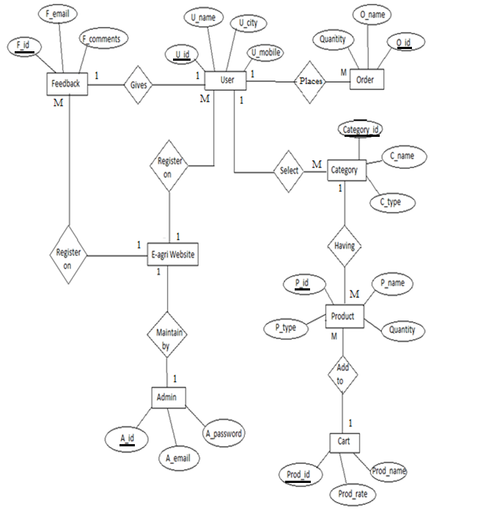

**UML Diagrams**

**Class Diagram**

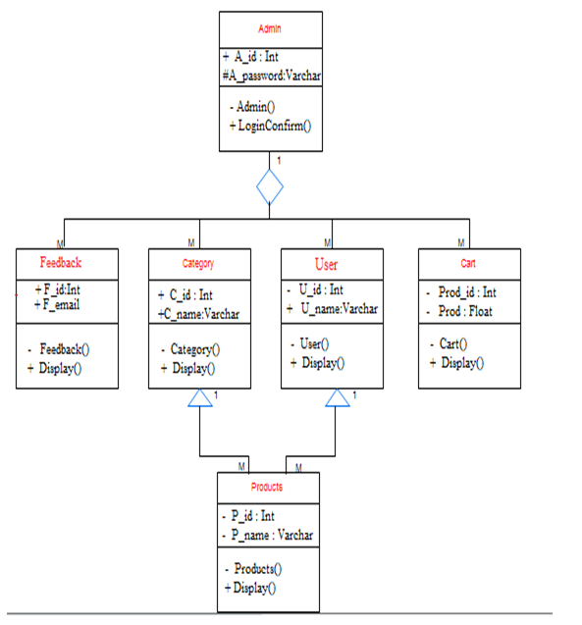 **Use Case Diagram**

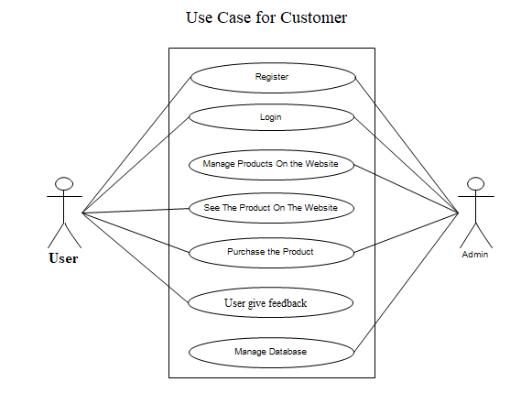

**Sequence Diagram**

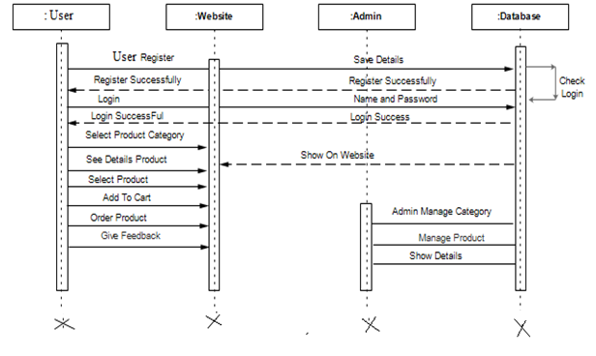

**Deployment Diagram**

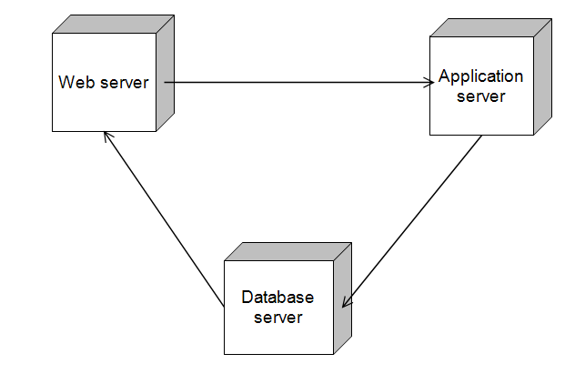

**Activity Diagram**

**Admin Customer**

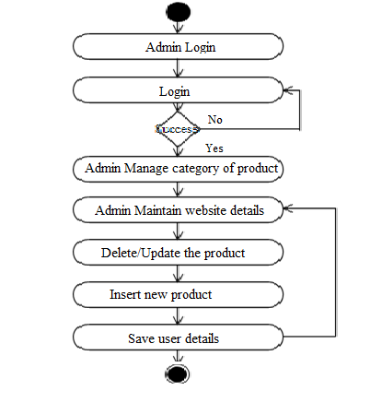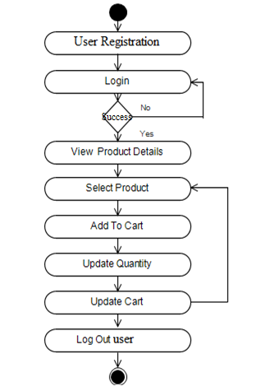

**Collaboration Diagram**

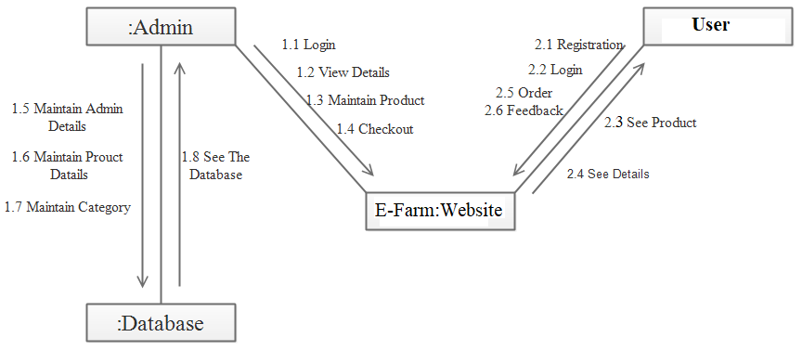

**Component Diagram**

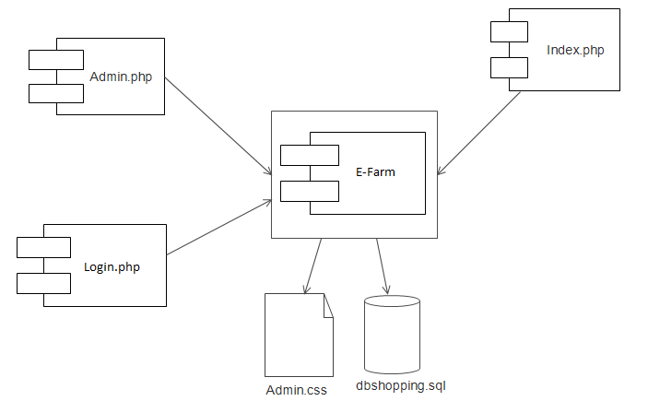

**Data Dictionary**

**Table admin**

|  |  |  |  |
| --- | --- | --- | --- |
| **Sr. No.** | **Field Name** | **Data Type** | **Size** |
| 1. | A_id | Int(Primary key) | 5 |
| 2. | A_email | Varchar | 30 |
| 3. | A_password | Varchar | 8 |

**Table User**

|  |  |  |  |
| --- | --- | --- | --- |
| Sr.No. | Field Name | Type | Size |
| 1. | U_id | Int(Primary key) | 5 |
| 2. | U_email | Varchar | 35 |
| 3. | U_password | Varchar | 15 |
| 4. | U _name | Varchar | 10 |
| 5. | U _lname | Varchar | 10 |
| 6. | U_city | Varchar | 15 |
| 7. | U_gender | Varchar | 8 |
| 8. | U _address | Varchar(50) | 50 |
| 9. | U_pincode | Int | 6 |
| 10. | U_mobile | Number | 10 |

**Table Category**

|  |  |  |  |
| --- | --- | --- | --- |
| **Sr.No.** | **Field Name** | **Data Type** | **Size** |
| 1. | Category_id | Int(Primary Key) | 5 |
| 2. | C_name | Varchar | 20 |
| 3. | C_type | Varchar | 15 |
| 4. | U_id | Int(Foreign Key) | 5 |

**Table Product**

|  |  |  |  |
| --- | --- | --- | --- |
| **Sr.No.** | **Field Name** | **Type** | **Size** |
| 1. | P_id | Int(Primary Key) | 5 |
| 2. | P_name | Varchar | 20 |
| 3. | P_type | Varchar | 15 |
| 4. | P_rate | Float | 7 |
| 5. | P_qty | Int | 10 |
| 6. | P_unit | Varchar | 10 |
| 7. | C_id | Int(Foreign Key) | 5 |
| 8. | Prod_id | Int(Foreign Key) | 5 |

**Table Cart**

|  |  |  |  |
| --- | --- | --- | --- |
| **Sr.No.** | **Field Name** | **Data Type** | **Size** |
| 1. | Prod_id | Int(Primary Key) | 5 |
| 2. | Prod_name | Varchar | 20 |
| 3. | Prod_type | Varchar | 15 |
| 4. | Prod_rate | Float | 10 |
| 5. | Prod_qty | Int | 5 |

|  |  |  |  |
| --- | --- | --- | --- |
| **Sr.No.** | **Field Name** | **Data Type** | **Size** |
| 1 | O_id | Int(Primary Key) | 5 |
| 2 | O_Name | Varchar | 30 |
| 3 | Quantity | Int | 10 |
| 4 | Amount | Money | 10 |
| 6 | U_id | Int(Foreign Key) | 5 |

**Order Table**

**TABLE FEEDBACK**

|  |  |  |  |
| --- | --- | --- | --- |
| Sr.No. | Field Name | Type | size |
| 1. | F_id | Int(Primary key) | 5 |
| 2. | F_name | Varchar | 30 |
| 3. | F_email | Varchar | 35 |
| 4. | F_comments | Varchar | 50 |
| 5. | F_mobile | Double | 10 |
| 6. | U_id | Int(Foreign Key) | 5 |

**INPUTSCREENS**

E-farm

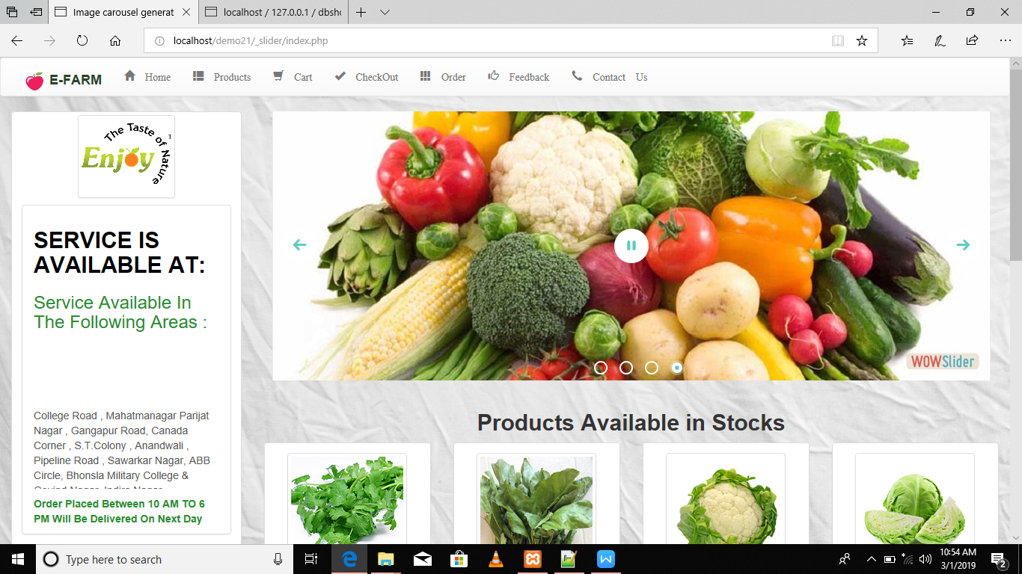

Home Page with Validations:

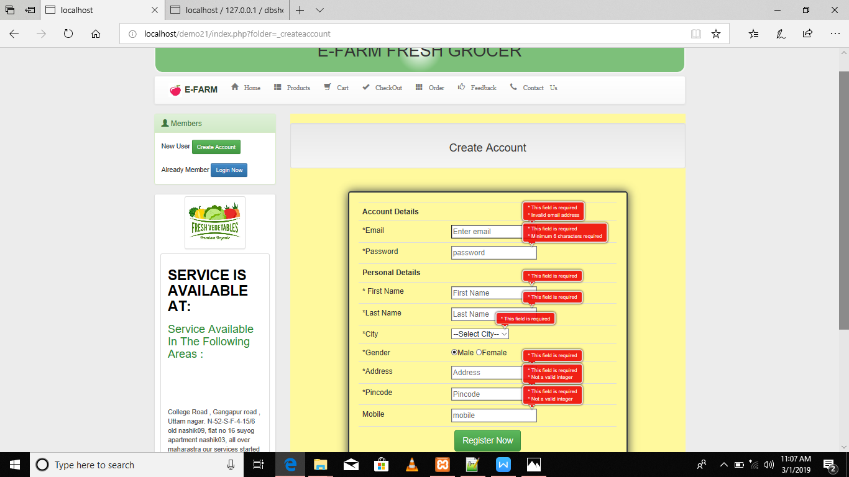

User Login:

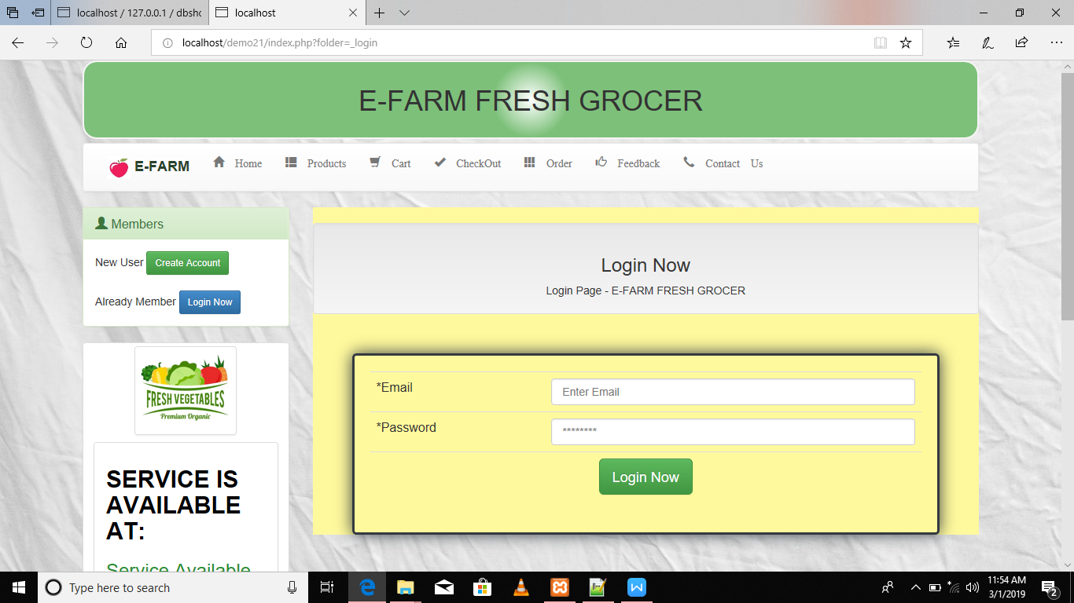

Products Details:

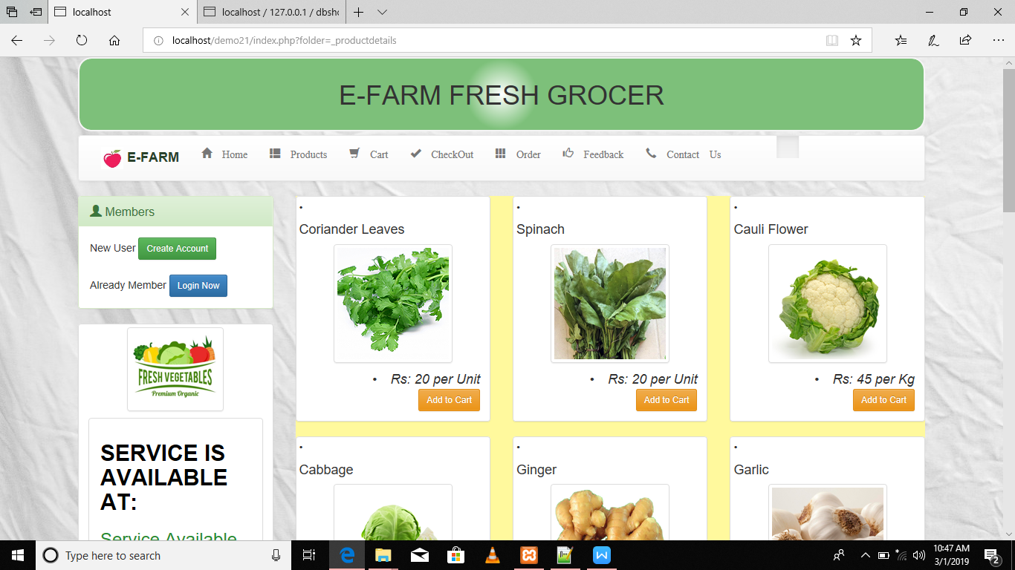

User select Product and add to cart:

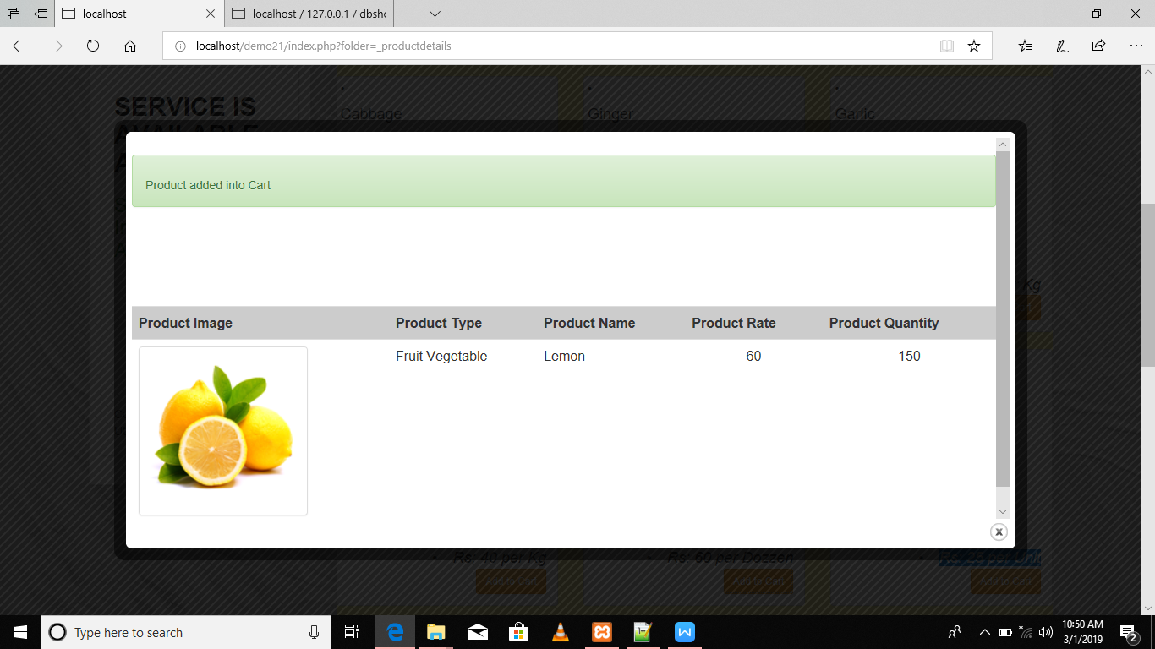

User see the products into cart:

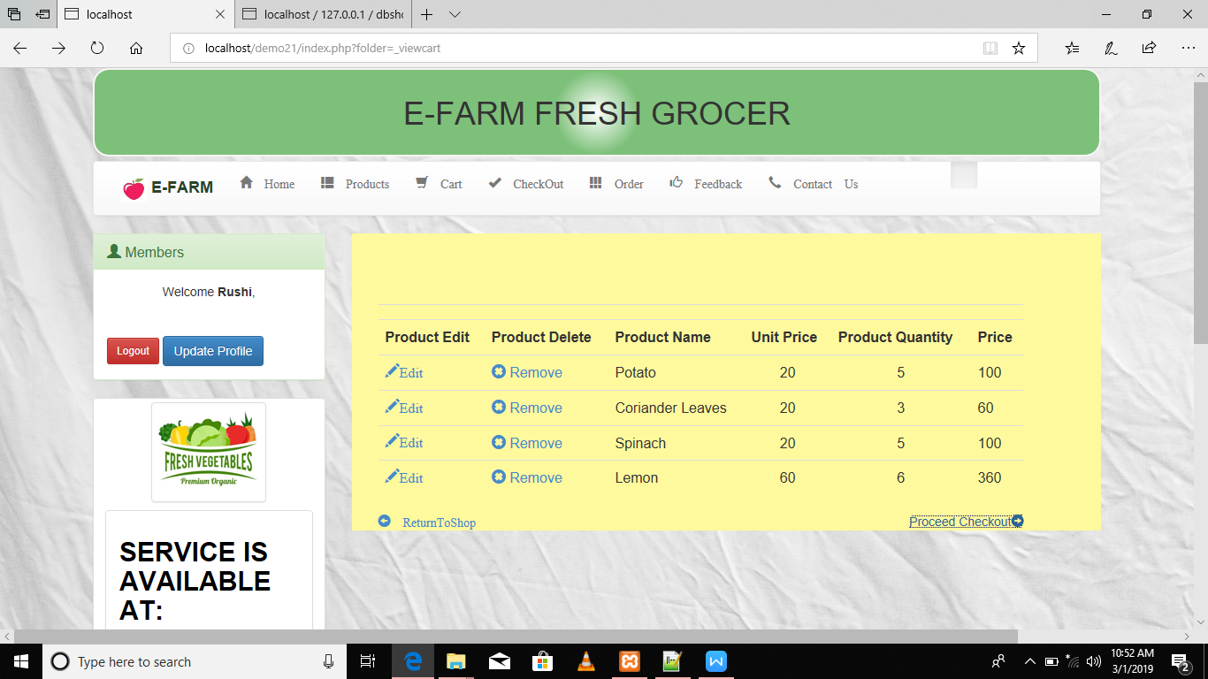

User see the checkout:

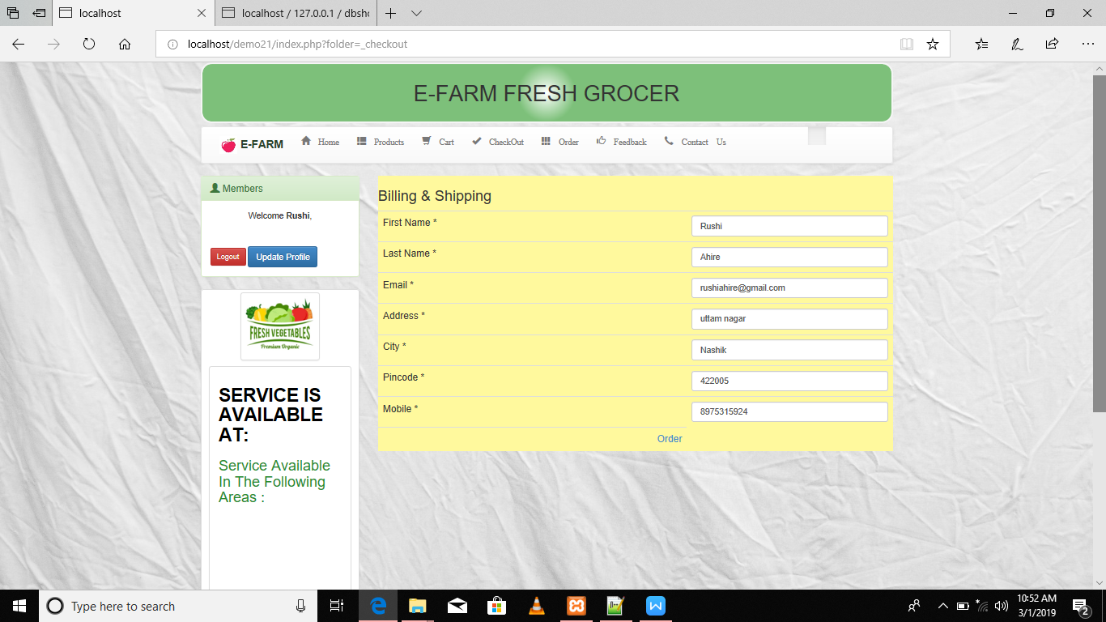

User see the order and total bill:

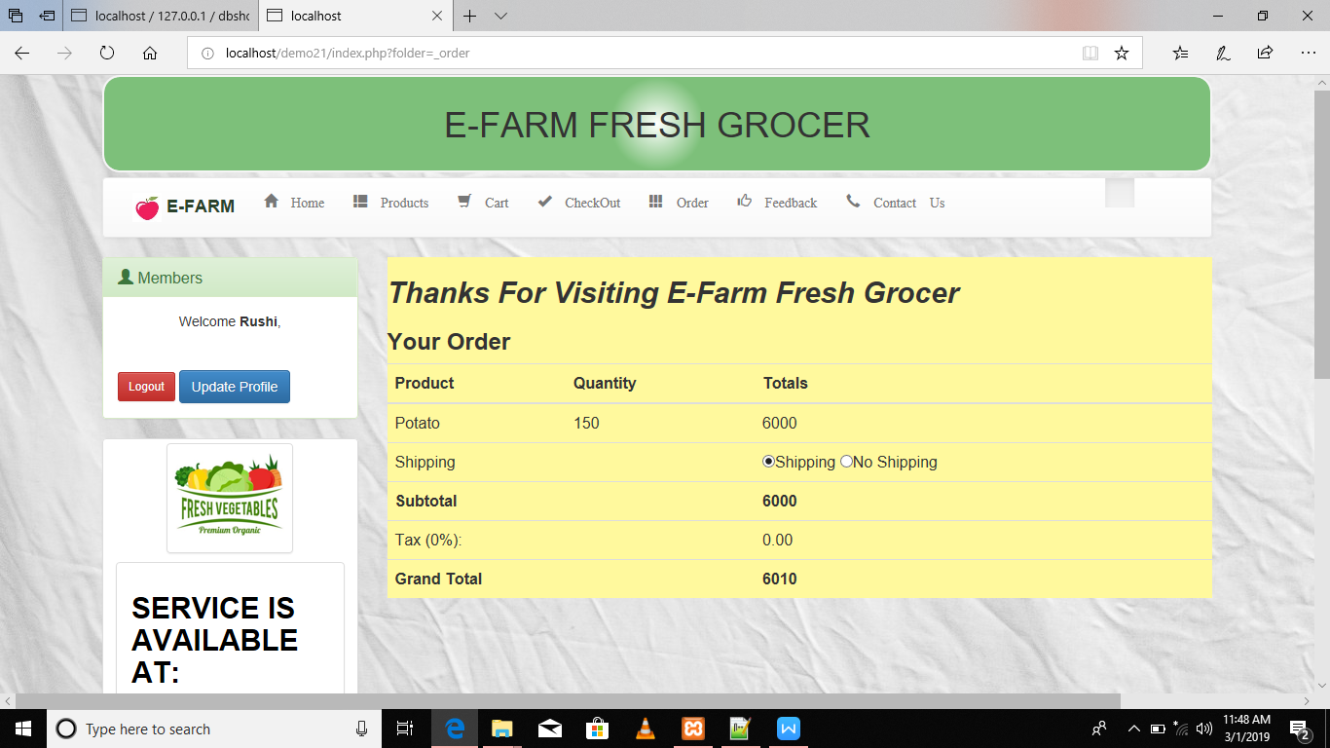

Any one who will visits the website can give a feedback:

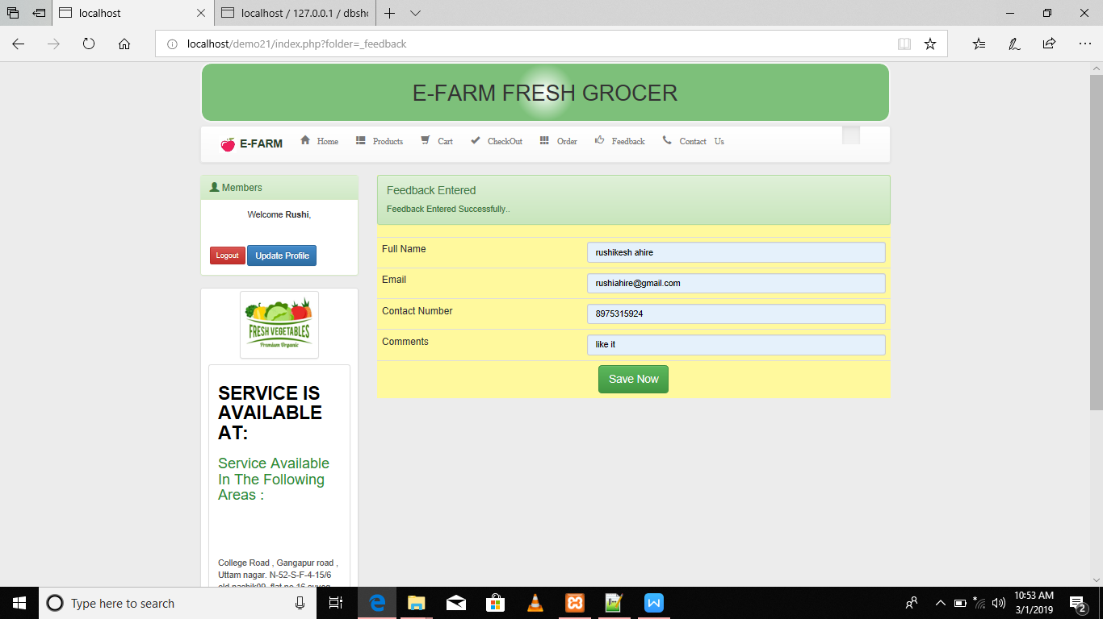

User can update the profile:

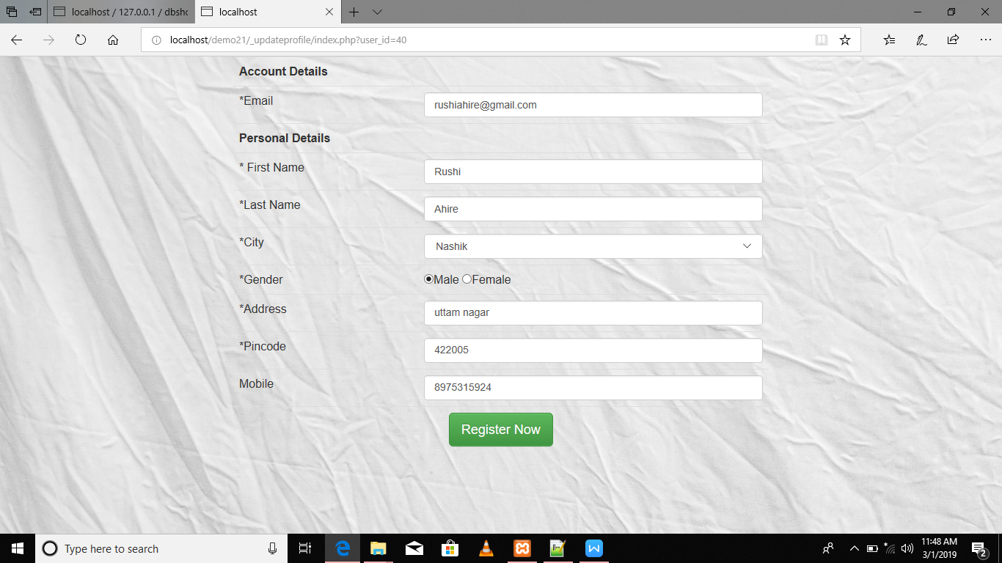

Admin Login:

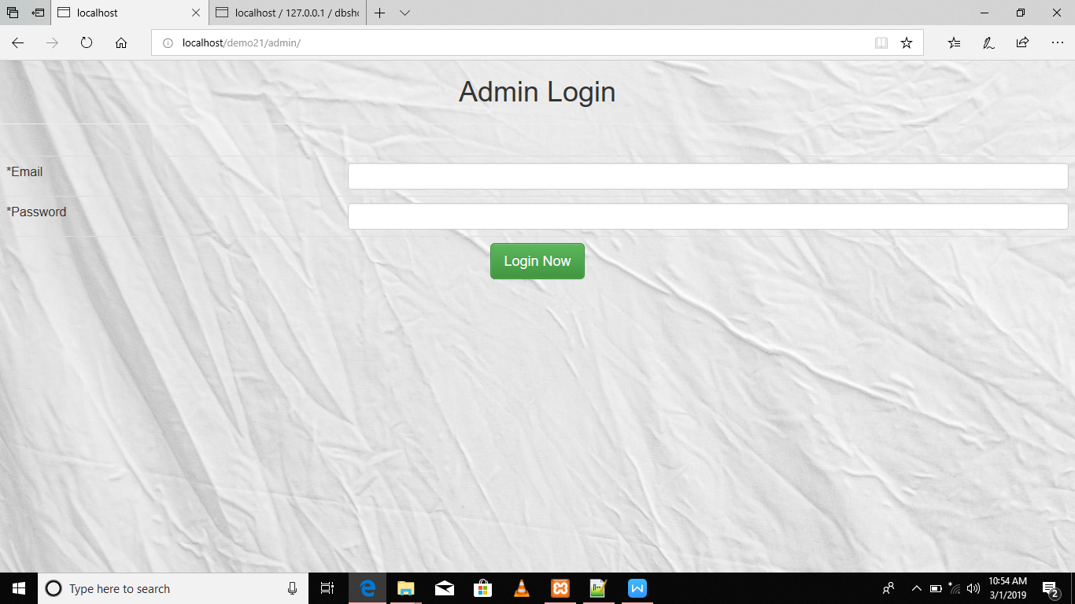

ProductDetails:

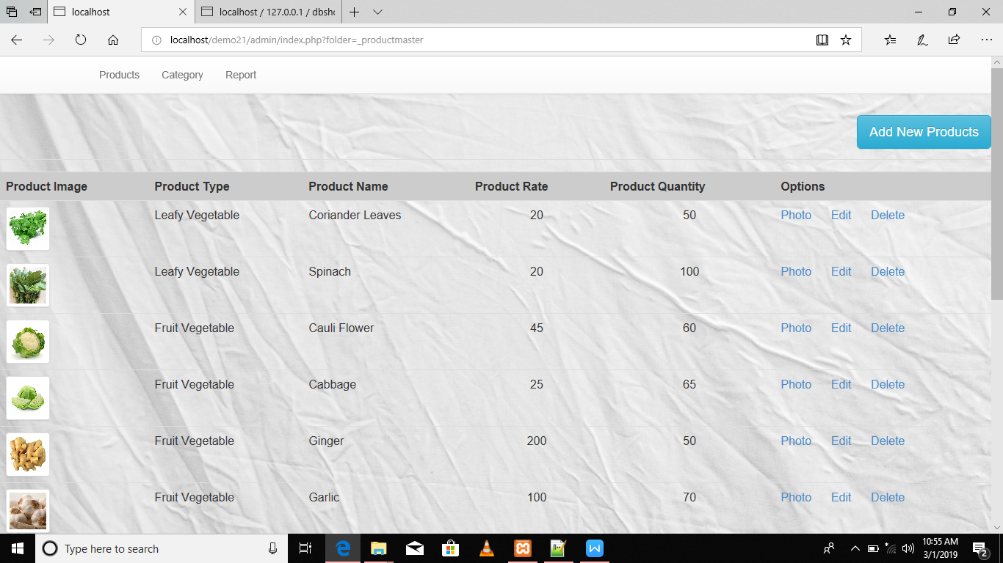

Category Details:

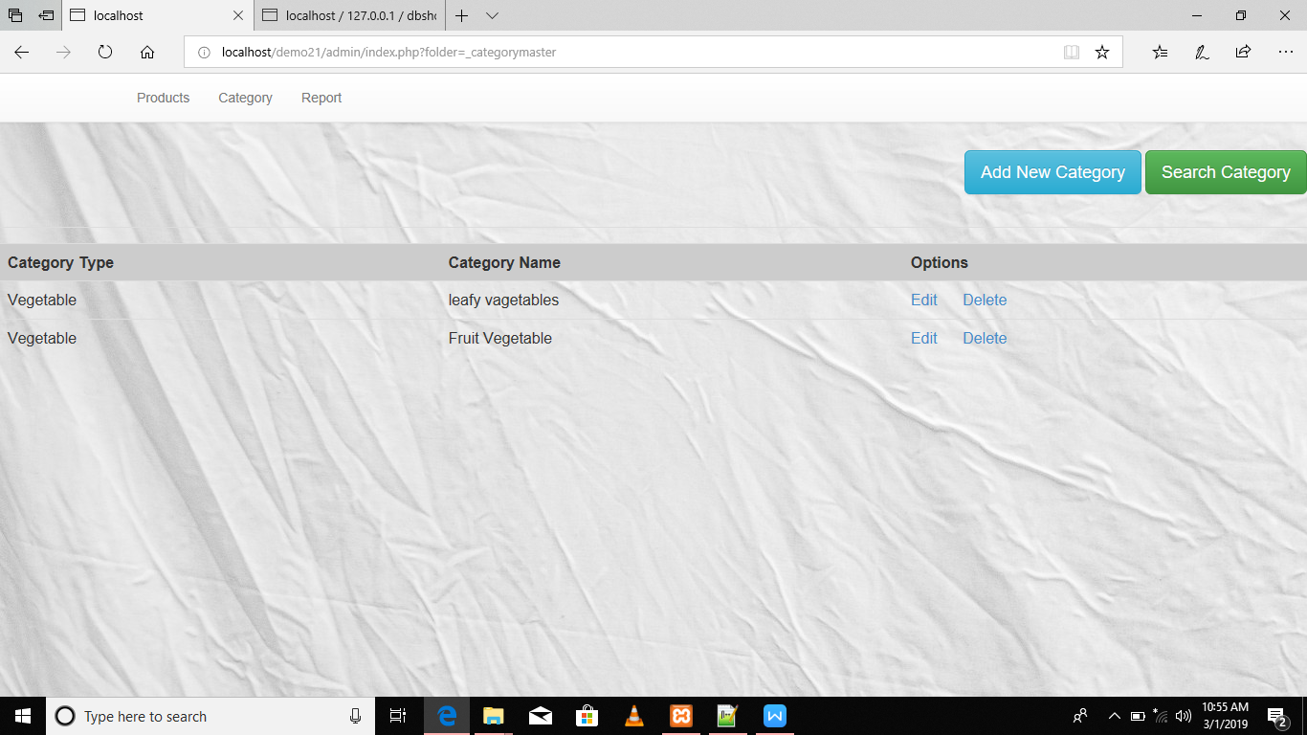

Reports:

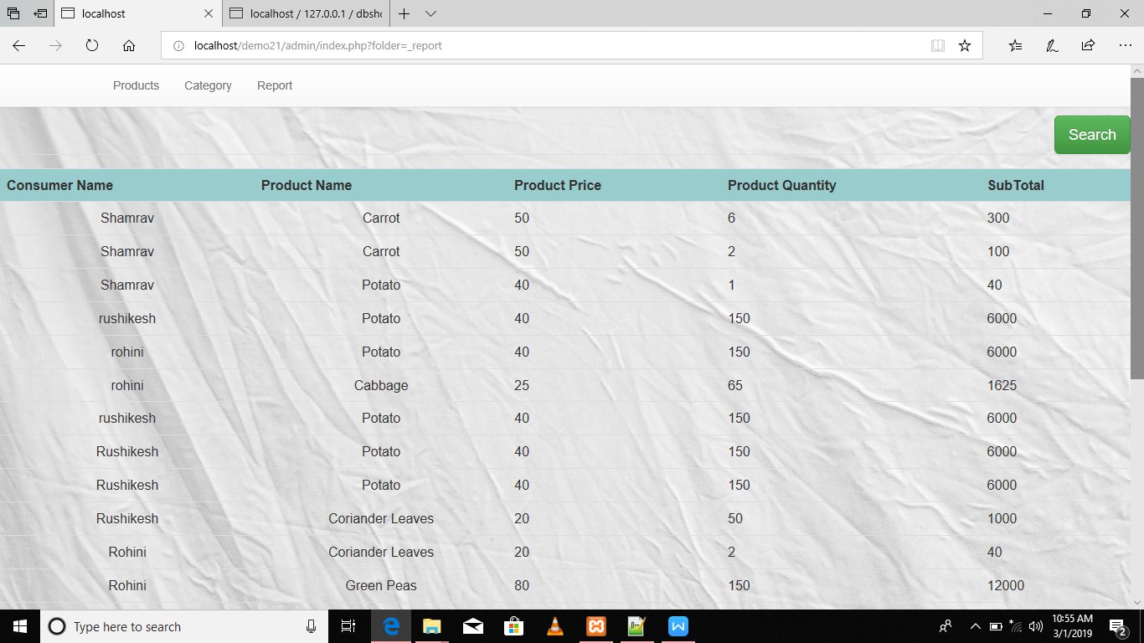

**Conclusion**

* Performance gain and better control of the system.
* The system can maintain large volumes of data easily.
* The processing is faster as compared to manual system.
* Reduction in access time & efforts involved.
* System is less expensive & accurate as compared to manual system.
* It produces timely reports & output.
* It provides improved& efficient services.

**Future Enhancement**

The system has wide scope in the future. All the limitation mentioned above could be fulfilled which will make it complete commercial system.

In future it can be enhanced with some more features like:

* Notifications of user cart, sales and discount

Offers etc.

* Shopping malls also connect with this.
* Advertisement of new products.

**Bibliography**

Here I would like to present the name of the books and the websites used for reference while analysis, designing, coding, testing and implementation of the system.

* Internet Programming - II
* www.color-hexcode.com
* [www.getbootstrap.com](http://www.getbootstrap.com)